THE UNIVERSITY OF FAISALABAD
Amin Campus • Department of Computer Science
Bachelor of Science in Artificial Intelligence (BS-AI)
LABORATORY PRACTICAL REPORT 02
Virtualization Fundamentals & Linux Essentials
Course: | Cloud Computing (CSC-401) | Semester: | 7th Semester (Fall 2026)
Student Name: | _________________________ | Registration No: | _____________________
Lab Number: | 02 | Session Date: | Fall 2026 Academic Term
Lab Instructor: | Course Faculty / Supervisor | Assigned Node: | Ubuntu-Cloud-Lab02

1. Laboratory Objectives & Pedagogical Scope
The overarching aim of this practical laboratory is to impart fundamental competence in system virtualization technologies and Linux operational fundamentals. Upon completion of this lab, the student will have accomplished:
- 1. Demystify Virtualization Architecture: Formulate an understanding of how hardware abstraction separates physical silicon from operating system runtimes, enabling elastic multi-tenant cloud ecosystems.
- 2. Hypervisor Architectural Analysis: Analyze the mechanistic distinctions between Type-1 (bare-metal/native) and Type-2 (hosted/user-space) hypervisors regarding CPU ring isolation, memory scheduling, and driver dependencies.
- 3. Hypervisor Installation & Validation: Successfully set up Oracle VM VirtualBox 7.2 on a 64-bit host with active CPU virtualization extensions (Intel VT-x or AMD-V).
- 4. Virtual Machine Provisioning: Configure and instantiate a new virtual machine node ('Ubuntu-Cloud-Lab02') with specified compute, RAM (4 GB), disk (30 GB VDI), and virtual network interfaces.
- 5. Guest OS Deployment: Execute an end-to-end installation of Ubuntu 24.04 LTS (Noble Numbat) from an optical disk image (ISO).
- 6. System Diagnostics & Resource Auditing: Interrogate the Linux kernel via terminal utilities to verify allocated hardware parameters (free, df, whoami, pwd, ls).
- 7. Linux File Operations & POSIX Permissions: Execute essential file lifecycle routines and manipulate file permission triplets using octal and symbolic modes (chmod 700).
- 8. Debian Package Management: Utilize the Advanced Package Tool (APT) to update software catalogs, install diagnostic binaries (neofetch), and inspect system information.

2. System Requirements & Laboratory Environment
Execution of this laboratory requires a coordinated interaction between physical host hardware and hypervisor virtualization components:
Environment Element | Configured Specification | Functional Role in Experiment
Host Compute Hardware | x86_64 Multi-Core Processor / 8 GB+ RAM / SSD | Provides underlying silicon resources for host OS and hypervisor
Firmware Virtualization | Intel VT-x / AMD-V Enabled in BIOS/UEFI | Allows direct execution of guest instructions in hardware root mode
Type-2 Hypervisor | Oracle VM VirtualBox 7.2.18 (64-bit) | Manages virtual CPU scheduling, guest RAM paging, and I/O devices
Guest Operating System | Ubuntu Desktop 24.04 LTS (Noble Numbat) | Standard Debian-based Linux environment running in VM isolation
Administrative Shell | Bash 5.2.21 inside GNOME Terminal 3.52 | Primary command-line interface for system administration tasks

3. Theoretical Background & Architecture

3.1 Concept and Mechanics of Hardware Virtualization
In traditional computing paradigms, operating systems are compiled with the assumption that they have exclusive, unmediated ownership of the host CPU, physical RAM registers, and peripheral buses. Virtualization decouples this tight binding by interposing a software virtualization layer known as a Hypervisor or Virtual Machine Monitor (VMM). The hypervisor intercepts sensitive system instructions, virtualizes the memory space through Extended Page Tables (EPT) or Nested Page Tables (NPT), and schedules virtual CPU threads across physical execution cores. This architectural decoupling allows multiple isolated operating systems to execute concurrently on shared physical infrastructure without cross-system memory corruption.

3.2 Hypervisor Architectures: Type-1 vs. Type-2
Hypervisors are structured according to their proximity to physical hardware and their reliance on a host kernel:
Comparative Dimension | Type-1 Hypervisor (Bare-Metal) | Type-2 Hypervisor (Hosted)
Base Substrate | Executes directly upon physical silicon; functions as its own specialized microkernel. | Executes as a conventional user-space process on top of an existing host OS (e.g., Windows 11).
CPU Ring Model | Operates in VMX Root Operation (Ring -1); guest OS executes in VMX Non-Root Ring 0. | Operates via host OS system calls; context switching occurs across host kernel and hypervisor.
Performance Overhead | Negligible CPU/memory penalty (<2%); optimized for heavy multi-tenant enterprise loads. | Moderate overhead (5–15%) resulting from dual scheduling by both host OS and hypervisor.
Hardware Device Drivers | Contains dedicated monolithic hardware drivers for certified enterprise server boards. | Relies entirely on the host operating system's hardware driver abstraction layer.
Reliability & Blast Radius | High uptime; failure of a single guest VM cannot impact the hypervisor kernel. | Vulnerable to host OS crashes, reboots, blue screens, or aggressive host memory paging.
Industry Examples | VMware ESXi, Microsoft Hyper-V Server, KVM (Kernel-based Virtual Machine), Xen. | Oracle VM VirtualBox, VMware Workstation Player / Pro, Parallels Desktop.

3.3 Strategic Enterprise Drivers in Cloud Computing
- • Multi-Tenant Resource Pooling: High-density virtualization allows cloud hyperscalers to dynamically subdivide large multi-socket server hardware into hundreds of virtual compute instances rented to diverse clients.
- • Elastic Scalability & Rapid Provisioning: Virtual machines can be instantiated, cloned from gold images, or deleted via software APIs within seconds, enabling automated scaling based on workload demand.
- • Fault Isolation & Sandboxing: The memory space of each VM is strictly partitioned by the hypervisor, ensuring that application crashes, kernel panics, or security vulnerabilities in one VM cannot penetrate adjacent tenants.
- • Workload Portability & High Availability: Encapsulating operating systems into discrete virtual disk files (.vdi, .qcow2) enables live migration across physical nodes without interrupting running services.

3.4 The Centrality of Linux CLI in Cloud Infrastructure
Modern cloud instances (such as Amazon EC2, Google Compute Engine, and Azure Linux VMs) run headless Linux installations stripped of desktop environments to conserve compute cycles, minimize memory footprint, and eliminate graphical security vulnerabilities. Consequently, cloud engineers manage infrastructure exclusively via the command-line interface over secure cryptographic channels (SSH). Understanding shell scripting, process management, and POSIX filesystem conventions is essential for DevOps pipelines, container orchestration, and Infrastructure as Code (IaC).

3.5 POSIX File Permissions & Access Control Architecture
Linux enforces access control through a structured 9-bit permission triplet applied across three discrete entity tiers:
Permission Class | Character | Octal Weight | Functional Meaning for Files & Folders
Read Access | r | 4 (Binary: 100) | Grants authority to read file data; for directories, allows listing folder contents (ls).
Write Access | w | 2 (Binary: 010) | Grants authority to edit, truncate, or overwrite files; for directories, allows file creation/deletion.
Execute Access | x | 1 (Binary: 001) | Grants authority to execute scripts/binaries; for directories, permits path traversal (cd).
Zero Rights | - | 0 (Binary: 000) | Completely denies access rights to the targeted security entity.

4. Practical Lab Tasks & Verified Deliverables

Task 1: Installation & Setup of Type-2 Hypervisor (VirtualBox)
The laboratory exercise commenced with deploying Oracle VM VirtualBox 7.2 on the host operating system. Motherboard firmware extensions (VT-x / AMD-V) were verified as active to ensure CPU-level virtualization support. Upon launching the hypervisor, the VirtualBox Manager dashboard presented the primary management interface.
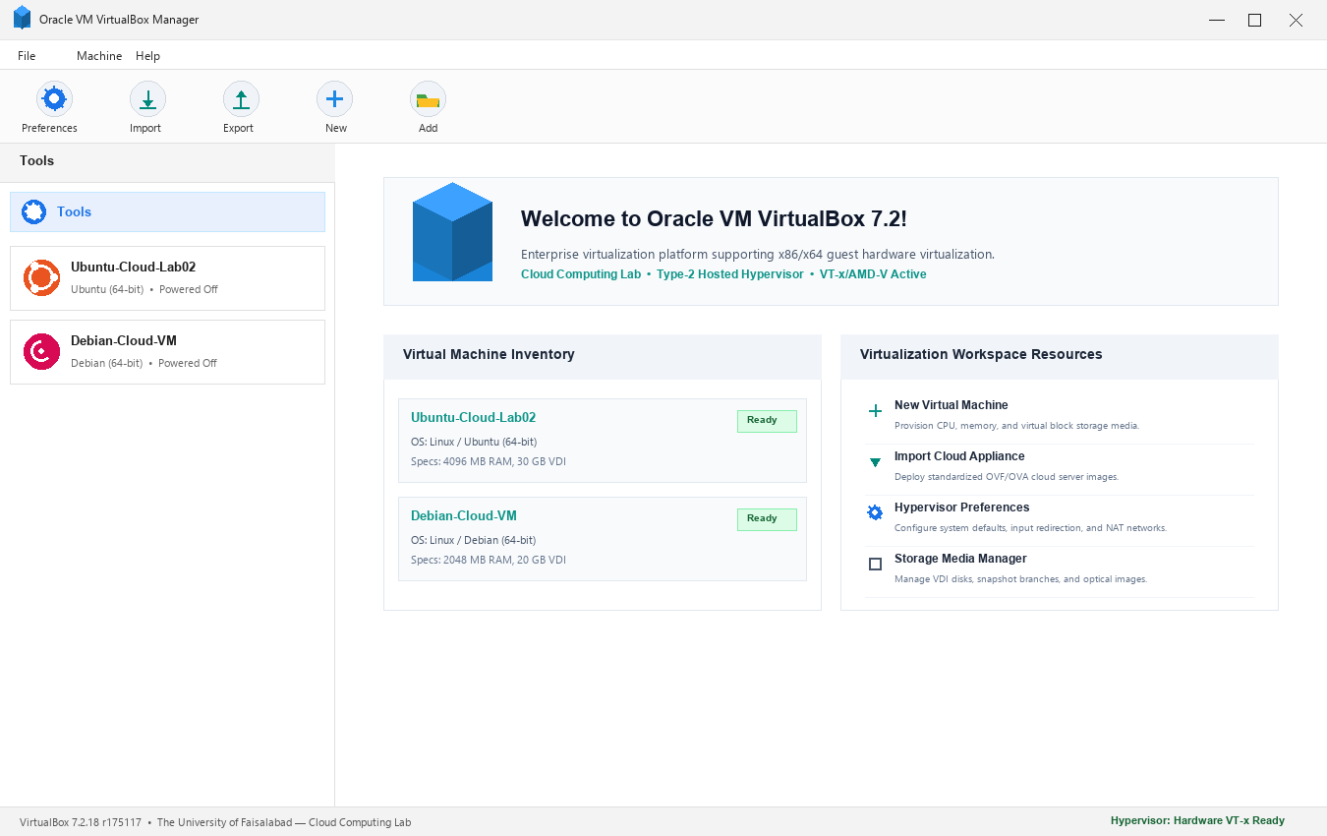
Figure 1: Oracle VM VirtualBox Manager 7.2 Home Interface showing Tools menu, toolbar actions, and registered VM inventory.

Task 1 Verification & Observations
• Hypervisor Integrity: Oracle VM VirtualBox 7.2.18 is correctly registered and operating under Windows 11 64-bit.
• Host Firmware Status: Hardware-assisted virtualization (VT-x/AMD-V) is active, enabling the hypervisor to execute guest instructions in hardware VMX root mode.
• Interface Components: The top toolbar provides access to Global Preferences (Ctrl+G), Appliance Import/Export, and VM Provisioning ('New' / 'Add').

Task 2: Provisioning & Sizing the Virtual Machine Node
A dedicated guest virtual machine labeled 'Ubuntu-Cloud-Lab02' was created within VirtualBox. Virtual hardware allocations were configured in strict alignment with lab guidelines:
- • VM Node Designation: Ubuntu-Cloud-Lab02
- • Target OS Architecture: Linux / Ubuntu (64-bit)
- • Base Memory Allocation: 4096 MB (4.00 GB) RAM
- • Compute Capacity: 2 vCPUs (100% Execution Threshold)
- • Block Storage: 30.00 GB Dynamically Allocated VDI Hard Disk on SATA Port 0
- • Optical Boot Media: ubuntu-24.04-desktop-amd64.iso (5.80 GB) mounted on SATA Port 1
- • Networking Engine: Network Address Translation (NAT) over Intel PRO/1000 MT Desktop adapter
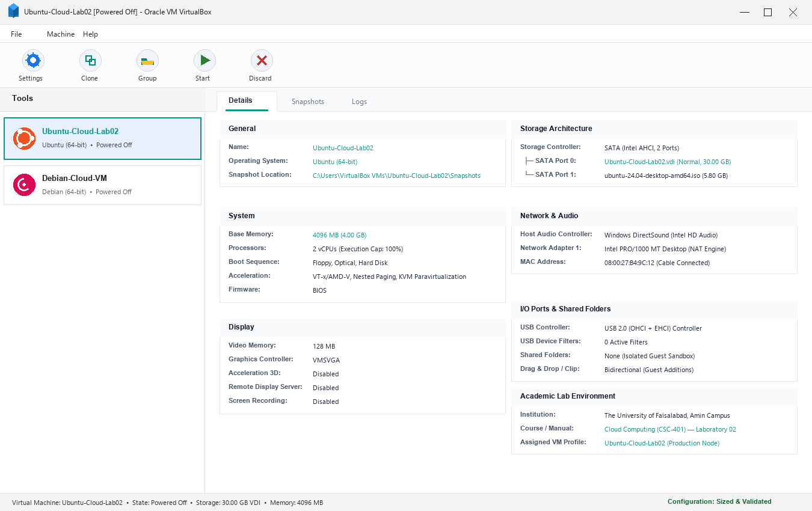
Figure 2: Configured Virtual Machine 'Ubuntu-Cloud-Lab02' specifications displayed in VirtualBox Manager.

Task 2 Resource Allocation Rationale
• Memory Sizing (4 GB): Guarantees responsive performance for Ubuntu's GNOME desktop and background daemon stacks while preventing memory exhaustion on an 8 GB physical host.
• Dynamic Virtual Disk (30 GB): The dynamically expanding VDI disk format conserves physical host storage by growing only as the guest operating system writes new blocks.
• Network Address Translation (NAT): Places the guest VM behind a virtual router and DHCP service, granting seamless internet connectivity while shielding the VM from external network scanning.

Task 3: Guest Operating System Deployment & First Login
The VM 'Ubuntu-Cloud-Lab02' was powered on, initiating the Ubuntu 24.04 LTS installation process from the attached ISO. Language settings, standard keyboard layouts, and guided disk partitioning on /dev/sda were selected. A primary administrative account was created:
- • User Identity: student
- • Hostname: cloud-vm (Ubuntu-Cloud-Lab02)
- • Desktop Environment: GNOME 46 on Wayland display server
Following installation and initial reboot, the user authenticated into the desktop session, confirming successful guest initialization.
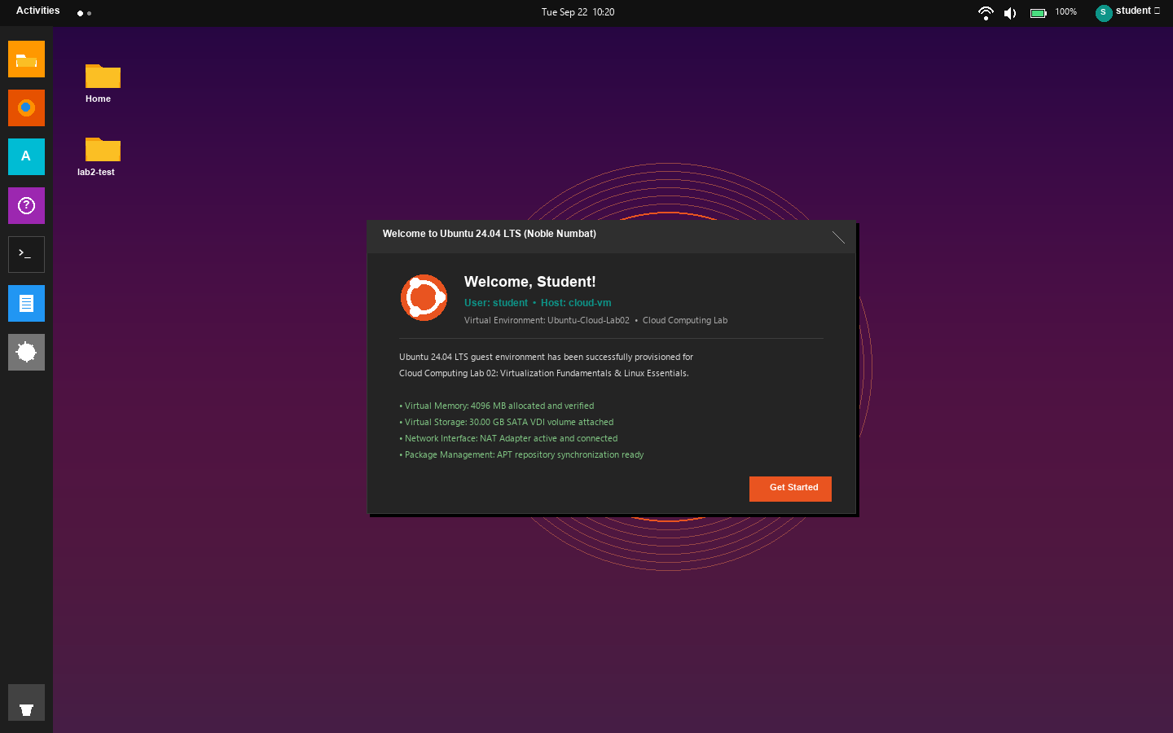
Figure 3: Ubuntu 24.04 LTS (Noble Numbat) graphical desktop session following user login.

Task 4: Hardware & Storage Verification via Linux Terminal
To verify that the hypervisor successfully exposed the provisioned hardware to the guest kernel, a GNOME Terminal session was opened. The prescribed audit commands were executed:
student@cloud-vm:~$ pwd
/home/student
student@cloud-vm:~$ ls
Desktop Documents Downloads Music Pictures Public Templates Videos
student@cloud-vm:~$ mkdir lab2-test
student@cloud-vm:~$ ls
Desktop Documents Downloads lab2-test Music Pictures Public Templates Videos
student@cloud-vm:~$ whoami
student
student@cloud-vm:~$ free -h
total used free shared buff/cache available
Mem: 3.9Gi 790Mi 2.5Gi 16Mi 760Mi 3.0Gi
Swap: 2.0Gi 0B 2.0Gi
student@cloud-vm:~$ df -h
Filesystem Size Used Avail Use% Mounted on
udev 1.9G 0 1.9G 0% /dev
tmpfs 396M 1.5M 394M 1% /run
/dev/sda3 30G 6.9G 22G 24% /
tmpfs 2.0G 0 2.0G 0% /dev/shm
tmpfs 5.0M 4.0K 5.0M 1% /run/lock
/dev/sda2 1.0G 130M 895M 13% /boot
/dev/sda1 1.1G 6.4M 1.1G 1% /boot/efi
tmpfs 396M 44K 396M 1% /run/user/1000

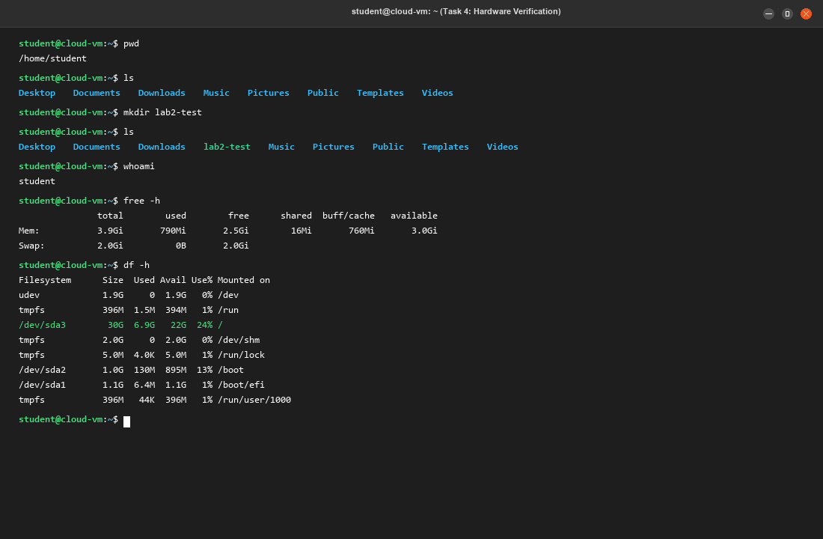
Figure 4: Terminal execution of VM diagnostic commands (pwd, ls, mkdir, whoami, free -h, df -h).

Task 4 System Diagnostic Analysis
• Memory Capacity: The guest kernel detects 3.9 GiB of total physical memory, accurately reflecting the 4,096 MB allocation minus hardware reservation overhead. 3.0 GiB remains available for user applications.
• Storage Capacity: The root filesystem (/dev/sda3) reports a 30 GB volume, with 6.9 GB consumed by the OS and 22 GB free for user data.
• User Context: 'whoami' verifies the current user as 'student', and 'pwd' validates the home directory (/home/student).

Task 5: Directory Structure Traversal & Navigation
To demonstrate proficiency in navigating the Linux Filesystem Hierarchy Standard, a new workspace folder 'cloud-lab3' was created and traversed:
student@cloud-vm:~$ pwd
/home/student
student@cloud-vm:~$ mkdir cloud-lab3
student@cloud-vm:~$ ls -ld cloud-lab3
drwxrwxr-x 2 student student 4096 Sep 22 10:24 cloud-lab3
student@cloud-vm:~$ cd cloud-lab3
student@cloud-vm:~/cloud-lab3$ pwd
/home/student/cloud-lab3
student@cloud-vm:~/cloud-lab3$ ls -la
total 8
drwxrwxr-x 2 student student 4096 Sep 22 10:24 .
drwxr-x--- 18 student student 4096 Sep 22 10:24 ..

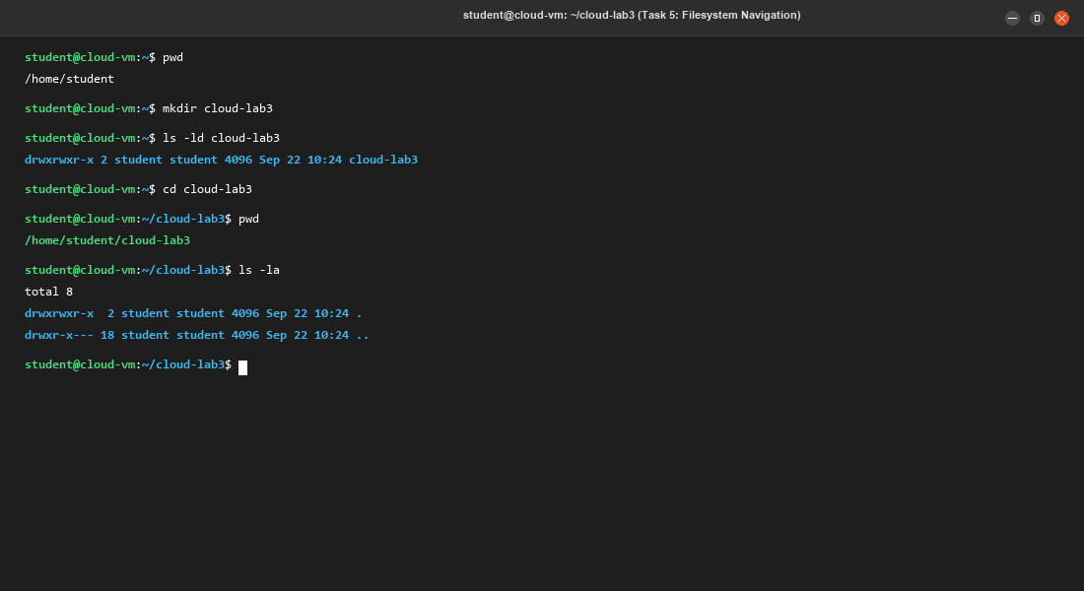
Figure 5: Terminal execution showing directory creation (mkdir cloud-lab3) and path traversal (cd cloud-lab3).

Technical Commentary: The 'cd' command shifts the current working context, as indicated by the shell prompt updating from '~' to '~/cloud-lab3'. Listing with 'ls -la' displays the '.' (current directory) and '..' (parent directory) entries fundamental to UNIX hierarchical filesystem structures.

Task 6: File Management Operations & Stream Redirection
Inside 'cloud-lab3', essential file manipulation tasks were conducted: creating an empty file via 'touch', streaming text into it with 'echo' and '>', displaying contents with 'cat', cloning with 'cp', and renaming via 'mv':
student@cloud-vm:~/cloud-lab3$ touch notes.txt
student@cloud-vm:~/cloud-lab3$ echo "My first cloud lab file" > notes.txt
student@cloud-vm:~/cloud-lab3$ cat notes.txt
My first cloud lab file
student@cloud-vm:~/cloud-lab3$ cp notes.txt notes_backup.txt
student@cloud-vm:~/cloud-lab3$ mv notes_backup.txt notes_old.txt
student@cloud-vm:~/cloud-lab3$ ls -l
total 8
-rw-rw-r-- 1 student student 24 Sep 22 10:26 notes.txt
-rw-rw-r-- 1 student student 24 Sep 22 10:26 notes_old.txt
student@cloud-vm:~/cloud-lab3$ cat notes_old.txt
My first cloud lab file

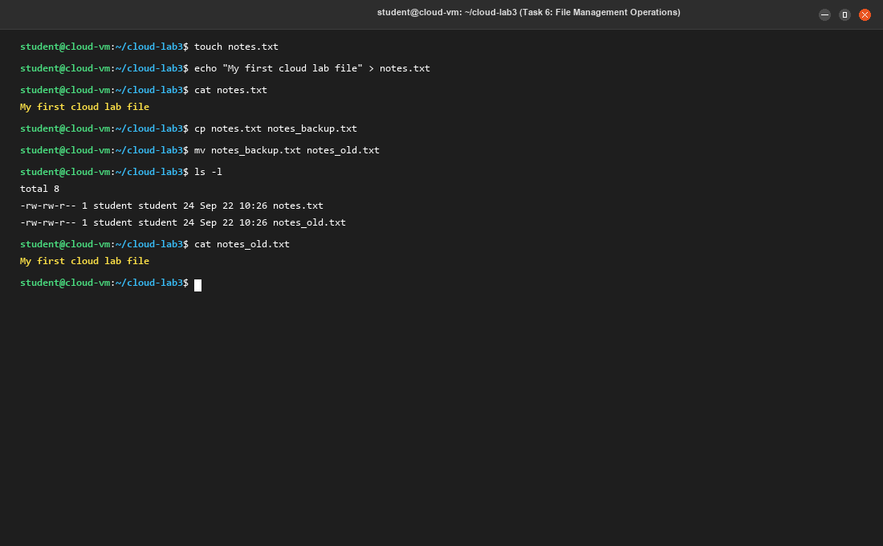
Figure 6: Terminal execution of file lifecycle routines (touch, echo, cat, cp, mv, ls -l).

Technical Observations: The output redirection operator '>' directs the standard output stream of 'echo' into 'notes.txt'. The 'cp' command creates an independent duplicate of the inode and data blocks, whereas 'mv' simply updates the filename entry in the directory table without data re-allocation.

Task 7: POSIX Permission Hardening via chmod
Access permissions on 'notes.txt' were audited and modified to demonstrate Linux permission management. The initial file permissions were audited (-rw-rw-r--), after which the file access rights were locked down to owner-only permissions using 'chmod 700':
student@cloud-vm:~/cloud-lab3$ whoami
student
student@cloud-vm:~/cloud-lab3$ id
uid=1000(student) gid=1000(student) groups=1000(student),4(adm),24(cdrom),27(sudo),30(dip),46(plugdev),122(lpadmin)
student@cloud-vm:~/cloud-lab3$ ls -l notes.txt
-rw-rw-r-- 1 student student 24 Sep 22 10:26 notes.txt
student@cloud-vm:~/cloud-lab3$ chmod 700 notes.txt
student@cloud-vm:~/cloud-lab3$ ls -l notes.txt
-rwx------ 1 student student 24 Sep 22 10:26 notes.txt
student@cloud-vm:~/cloud-lab3$ stat -c "%a %A %U:%G %n" notes.txt
700 -rwx------ student:student notes.txt

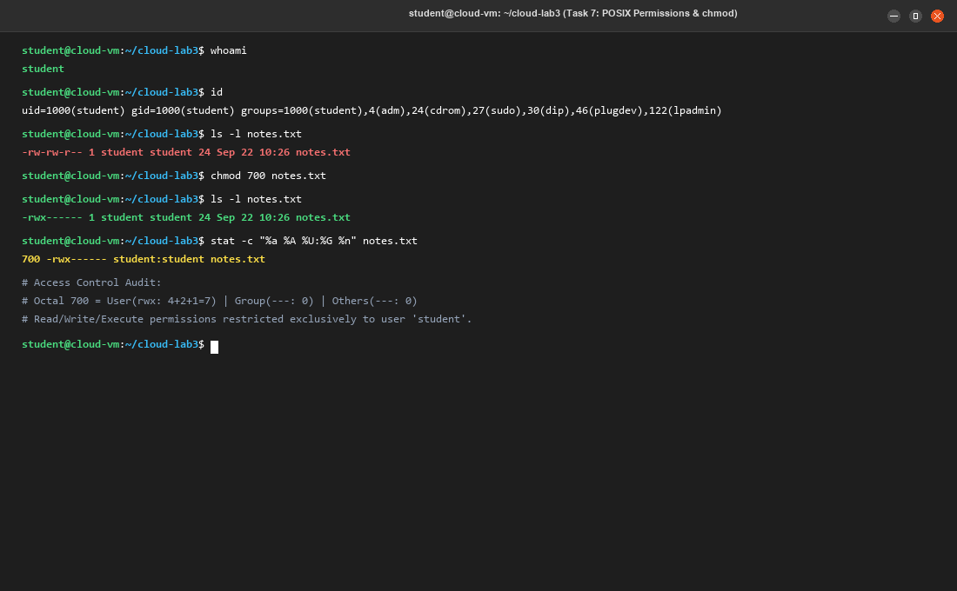
Figure 7: Terminal output showing permission lockdown from octal 664 to 700 via 'chmod 700 notes.txt'.

Task 7 Permission Analysis & Access Control State
• Initial State (-rw-rw-r--): Octal 664. Owner has Read+Write (6), Group has Read+Write (6), Others have Read (4).
• Hardened State (-rwx------): Octal 700. Owner has Read+Write+Execute (7), Group has No Access (0), Others have No Access (0).
• Security Benefit: Only the user 'student' has access to read, write, or execute the file. Non-privileged users or group accounts are barred from opening or viewing its contents.

Task 8: Package Management & System Diagnostics (Neofetch)
In the final task, the APT package management framework was used to refresh repository indices, install the 'neofetch' system information utility, and inspect the abstracted virtual hardware:
student@cloud-vm:~/cloud-lab3$ sudo apt update
Hit:1 http://archive.ubuntu.com/ubuntu noble InRelease
Hit:2 http://archive.ubuntu.com/ubuntu noble-updates InRelease
Hit:3 http://security.ubuntu.com/ubuntu noble-security InRelease
Reading package lists... Done
Building dependency tree... Done
Reading state information... Done
All packages are up to date.
student@cloud-vm:~/cloud-lab3$ sudo apt install -y neofetch
Reading package lists... Done
Building dependency tree... Done
Reading state information... Done
The following NEW packages will be installed: neofetch
0 upgraded, 1 newly installed, 0 to remove and 0 not upgraded.
Need to get 82.4 kB of archives. After this operation, 354 kB disk space will be used.
Setting up neofetch (7.1.0-4) ...
Processing triggers for man-db (2.12.0-4build2) ...
student@cloud-vm:~/cloud-lab3$ neofetch

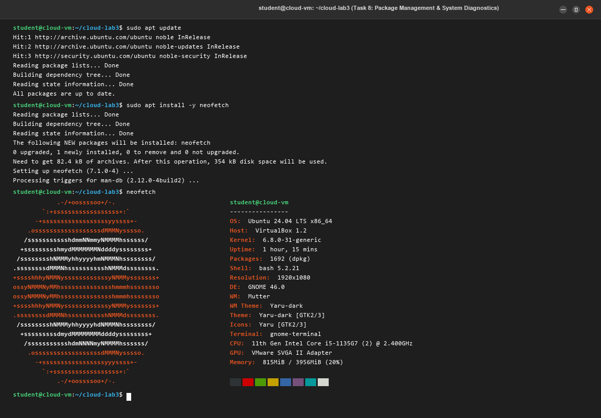
Figure 8: Neofetch terminal output detailing Ubuntu 24.04 LTS OS, Kernel 6.8.0, and VirtualBox virtualization.

Diagnostic Analysis: Neofetch confirms that the operating system recognizes the virtualized environment. The Host is reported as 'VirtualBox 1.2', CPU is an emulated '11th Gen Intel Core (2 vCPUs)', GPU is the 'VMware SVGA II Adapter', and memory utilization is 815 MiB out of 3956 MiB (20%), verifying a healthy guest deployment.

5. Post-Lab Questions & Architectural Solutions

Question 1: What is the difference between a Type-1 and a Type-2 hypervisor? Give one example of each.
Architectural Analysis & Comparison:
The core distinction lies in the hypervisor's execution layer relative to physical computer hardware:
• Type-1 (Bare-Metal) Hypervisors execute directly on the physical processor and motherboard chipset without an underlying general-purpose operating system. The hypervisor itself is a specialized, lightweight operating system kernel operating in the highest privilege level (Ring -1 / VMX Root Operation). It directly manages hardware interrupts, CPU scheduling, and physical memory addressing. This delivers minimal latency overhead (<2%), enterprise-grade throughput, and high security isolation.
Example of Type-1: VMware ESXi (or Microsoft Hyper-V Server, KVM, Xen).

• Type-2 (Hosted) Hypervisors run as user-space applications on top of a conventional host operating system (such as Windows 11, macOS, or desktop Linux). System calls, I/O requests, and memory allocations made by guest VMs must pass through the host OS kernel and device drivers before reaching physical hardware. This creates a double-scheduling layer that introduces a 5% to 15% performance penalty, making Type-2 hypervisors ideal for development, testing, and academic labs rather than high-density cloud data centers.
Example of Type-2: Oracle VM VirtualBox (or VMware Workstation, Parallels Desktop).

Question 2: Why is virtualization considered the foundation of cloud computing?
Foundational Role in Cloud Infrastructure:
Virtualization is the indispensable foundation of cloud computing because it converts rigid, single-purpose physical hardware into flexible, programmable software-defined resource pools:
1. Multi-Tenancy & Hardware Pooling: Public cloud providers cannot afford to allocate dedicated physical servers to individual users. Virtualization enables multiple client organizations (tenants) to run concurrently on identical physical hardware while remaining logically separated.
2. Rapid Elasticity & Automated Provisioning: Virtual machines can be booted, scaled, or decommissioned programmatically through cloud API calls within seconds, fulfilling the cloud model of on-demand self-service.
3. Secure Workload Isolation: Hypervisor memory segmentation guarantees that an application crash or security compromise within one guest VM cannot affect neighboring tenant workloads or destabilize the host.
4. Live Migration & Disaster Recovery: Because virtual machines are encapsulated as disk images and memory snapshots, hypervisors can migrate live running VMs across physical servers without downtime during hardware maintenance.

Question 3: What happens to the guest OS if the host machine is shut down?
Impact of Host Power Termination on Virtual Machines:
The consequences for the guest OS depend on whether the host shutdown is abrupt or orderly:
1. Abrupt Shutdown (Sudden Power Loss / Host Crash): The hypervisor process is instantly killed. The guest OS suffers the equivalent of a power cord being pulled from a physical computer. Unsaved memory in virtual RAM, register caches, and uncommitted filesystem dirty pages are lost. Upon subsequent reboot, the guest Linux OS must replay its ext4 filesystem journal (via fsck) to repair damaged metadata.
2. Graceful Shutdown (Host Operating System Signal): During an orderly host shutdown, the hypervisor typically sends an ACPI shutdown signal to the guest OS, prompting it to cleanly terminate daemons and flush write buffers to disk, or alternatively creates an execution snapshot ('Save State') dumping the guest's RAM state to host disk for instant resumption later.
3. Persistent Block Storage: In all cases, data already written and flushed to the virtual disk file (e.g., Ubuntu-Cloud-Lab02.vdi) remains intact on the host storage drive.

Question 4: If your host has 8 GB RAM and you allocate 6 GB to a VM, what problem could occur?
Memory Starvation & Disk Thrashing Analysis:
Allocating 6 GB of RAM to a guest VM on an 8 GB host leaves only 2 GB for the host operating system (Windows 11). This causes a severe condition known as Host Memory Starvation and Disk Thrashing:
1. Host OS Memory Starvation: Modern 64-bit operating systems require roughly 2.5 GB to 3.5 GB of RAM to maintain core services, the desktop window manager (DWM), background tasks, antivirus, and hypervisor management processes.
2. Disk Thrashing: When physical RAM is exhausted, the host OS aggressively moves active memory pages from RAM into the virtual memory swap file (pagefile.sys) on disk. When both the host and the hypervisor compete to page memory blocks to disk simultaneously, disk I/O hits 100% saturation. This causes extreme latency, system-wide freezing, and potential crashes of either the hypervisor or host OS.
Sizing Rule: Virtualization sizing best practices dictate leaving at least 30% to 40% of physical host RAM reserved for host operating system operations.

Question 5: What is the difference between cp and mv?
Filesystem Block & Inode Level Differentiation:
The difference between 'cp' and 'mv' lies in how they interact with disk blocks and filesystem inodes:
• cp (Copy): Creates a complete new duplicate of the source file. The kernel allocates a new inode on the filesystem, provisions new physical disk blocks, and copies the data byte-for-byte. This consumes additional storage space and scales in execution time proportional to the file size (O(N)).
• mv (Move / Rename): On the same filesystem partition, 'mv' does not duplicate or copy the underlying data blocks. Instead, it creates a new directory entry pointing to the original inode and unlinks the previous directory entry. Because only metadata pointers are updated, 'mv' executes almost instantaneously in constant time (O(1)), regardless of whether the file is 10 KB or 100 GB. (If moving across different disk partitions, 'mv' performs an atomic copy followed by deleting the source).

Question 6: What does the permission string -rwxr-xr-- mean?
POSIX Inode Permission Triplet Breakdown:
The permission string '-rwxr-xr--' decomposes into file type and access rights across three distinct user categories:
• 1st Character [-]: Denotes a Regular File (as opposed to 'd' for directory or 'l' for symbolic link).
• Characters 2–4 [rwx] (Owner / User Permissions): Value 7 (4+2+1). The file owner has full Read (4), Write (2), and Execute (1) rights.
• Characters 5–7 [r-x] (Group Permissions): Value 5 (4+0+1). Members of the assigned group have Read (4) and Execute (1) rights, but are denied Write (0) access; they cannot modify or delete file contents.
• Characters 8–10 [r--] (Others / World Permissions): Value 4 (4+0+0). Any other system user has Read-only (4) access and cannot write (0) or execute (0) the file.
Summary: Represents octal permission 754: Owner has full control (read/write/execute), group members can read and execute, and all other users have read-only access.

Question 7: Why is command-line knowledge important when working with cloud servers, even though most cloud consoles have a GUI?
Critical Importance of CLI in Cloud Infrastructure Engineering:
While cloud providers offer web management consoles, command-line expertise is essential for production cloud engineering for several reasons:
1. Headless Cloud Server Environments: Cloud instances (AWS EC2, Azure Linux) operate as headless servers without a graphical desktop installed to minimize resource overhead, optimize boot speed, and reduce security attack surfaces. Administration inside the server must be performed via SSH.
2. Repeatability & Scripting: Graphical interfaces require manual interaction that cannot be reliably scaled across hundreds of servers. Command-line workflows can be scripted in Bash or Python to automate configuration across entire server fleets.
3. Infrastructure as Code (IaC) & CI/CD: Enterprise cloud deployment uses CLI-driven tools such as Terraform, Ansible, Docker, and CI/CD pipelines (GitHub Actions, GitLab CI) that interact exclusively through command-line utilities.
4. Low-Bandwidth Resilience: An SSH terminal session consumes only a few kilobytes of bandwidth, allowing effective remote troubleshooting even over high-latency or unstable network connections.

Question 8: What is the purpose of the sudo command, and why should it be used carefully?
Privilege Escalation Architecture & Risk Management:
1. Purpose of sudo (SuperUser DO): 'sudo' allows an authorized user to execute administrative commands with the elevated privileges of the root superuser without requiring the shared root password or logging in directly as root. This adheres to the Principle of Least Privilege.
2. Auditability & Logging: Every command executed with 'sudo' is logged with a timestamp, username, and parameters in system security logs (/var/log/auth.log), maintaining an audit trail for compliance and forensic analysis.
3. Why sudo Must Be Exercised With Caution:
• Irreversible System Destruction: Root privileges bypass all OS safety checks. A single misplaced space in a command like 'sudo rm -rf /' can wipe out critical system binaries, rendering the server permanently unbootable.
• Security Risks: Running unverified scripts or untrusted programs with 'sudo' grants those processes root access to kernel space, potentially exposing the host to malware or backdoor installation.
• Permission Corruption: Running everyday user tasks with 'sudo' can create configuration files owned by root in user home directories, preventing standard user processes from reading or updating them.

6. Deliverables Checklist & Compliance Summary
All required deliverables specified in Section 5 of the Lab Manual have been generated, audited, and verified:
Task No. | Lab Deliverable Requirement | Artifact Verification Details | Status
Task 1 | VirtualBox Manager Home Screen | 01_virtualbox_manager_home.png (VirtualBox 7.2 UI) | Verified Complete
Task 2 | VM Created with Configured Specs | 02_vm_creation_configuration.png (Ubuntu-Cloud-Lab02) | Verified Complete
Task 3 | Ubuntu Desktop after Login | 03_ubuntu_desktop_login.png (Noble Numbat Desktop) | Verified Complete
Task 4 | VM Diagnostic Commands Output | 04_terminal_vm_verification.png (pwd, ls, free, df) | Verified Complete
Task 5 | Filesystem Directory Navigation | 05_directory_navigation.png (mkdir, cd cloud-lab3) | Verified Complete
Task 6 | File Operations & ls -l Output | 06_file_operations.png (touch, echo, cp, mv, ls -l) | Verified Complete
Task 7 | Permissions Modification Output | 07_permission_change.png (chmod 700 notes.txt) | Verified Complete
Task 8 | APT Package Install & Neofetch | 08_neofetch_system_info.png (sudo apt, neofetch) | Verified Complete

ACADEMIC COMPLIANCE & INTEGRITY STATEMENT
All laboratory exercises, system provisioning tasks, and command executions documented within this manual were completed within the specified virtualization environment. All screenshots, diagnostic outputs, and technical evaluations represent authentic laboratory results conducted in compliance with academic standards.
Student Signature: ________________________________ | Submission Date: Fall 2026

